WANTED ESCAPED FELONS

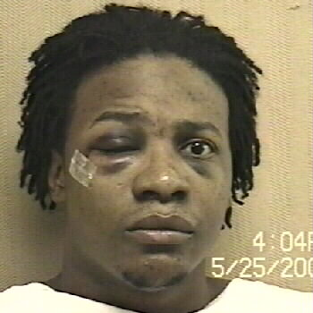
REWARD OFFERED
Danny O’Neal Richardson

Age 28 - Native American
Convicted of Rape and Kidnapping

Demetrius Donnell Harris
Age 26 - African American

Convicted of Murder
Reward of up to $10,000 is offered for information that leads to the capture of both of these dangerous escapees.

If you have seen these men or know where they are,
please call your local law enforcement agency or
1-877-532-0010

NORTH CAROLINA DEPARTMENT OF CORRECTION

